MULTIPLE LINEAR REGRESSION
Multiple regression it´s no big deal; in the StatQuest on simple linear regression we already covered most of the concepts we are going to cover here.
SIMPLE REGRESSION
This is just fitting a line to data; we are interested in the R-squared and p-value to evaluate how well that line fits the data.
$$y=b+a_{1}x$$
MULTIPLE REGRESSION
Here, we fit a plane or some higher-dimensional object to the data. All this means is that we´re adding additional data to the model.
$$y=b+a_{1}x+a_{2}z$$
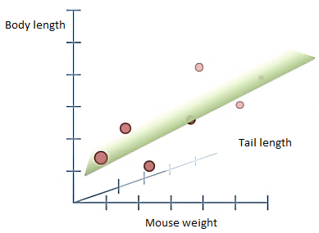
In the previous example, instead of just modelling body length by mouse weight, we modelled body length using mouse weight and tail length.
If we added additional factors, like amount of food eaten or time spent running in a wheel, those would be considered as additional dimensions that we add to our fancy equation:
$$Body lenght=b+a_{1}×Weight+a_{2}×Tail length+a_{3}×Food eaten+…$$
R-SQUARED
Calculating R-squared is the exact same for both simple and multiple regression:
$$R^{2}=\frac{SS\left(mean\right)-SS\left(fit\right)}{SS\left(mean\right)}$$
NOTE: For multiple regression you adjust R-squared to compensate for the additional parameters in the equation.
P-VALUE
Calculating $F$ and the p-value is pretty much the same …
$$F=\frac{\frac{SS\left(mean\right)-SS\left(fit\right)}{p_{fit}-p_{mean}}}{\frac{SS\left(fit\right)}{n-p_{fit}}}$$
In our example, $p_{fit}$ equals 3 and $p_{mean}$ is always 1.
COMPARE THE FITS
So far, we have compared this simple regression to the mean:
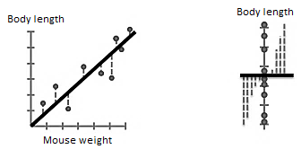
… and this multiple regression to the mean:
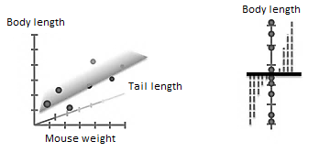
… but we can compare them to each other !
We can compare the simple regression to the multiple regression through the difference between their R-squared values.
Calculating the F value is the exact same as before, only this time we replace the ´mean´ stuff with the simple regression stuff.
$$F=\frac{\frac{SS\left(simple\right)-SS\left(multiple\right)}{p_{multiple}-p_{simple}}}{\frac{SS\left(multiple\right)}{n-p_{multiple}}}$$
If the difference in R-squared values between the simple and multiple regression is ´big´ and the p-value is ´small´, then adding tail length to the model is worth the trouble !!

